Procedural Boss Generation Feature
The procedural boss generation system in Crystal Defenders: The Last Stand is designed to ensure that every major enemy encounter feels dynamic, unpredictable, and engaging. Instead of relying on pre-designed bosses with fixed attributes, this system creates unique boss entities using a layered approach of statistical scaling, archetype identity, and ability selection. By combining wave-based progression, weighted randomness, and visual feedback, the feature introduces a sense of escalating challenge while maintaining replay value.
At the core of this system lies the stat scaling process. Each boss begins with a set of base attributes Health, Damage, and Movement Speed which grow proportionally with the player's progression through waves. These base stats are then further modified by a difficulty multiplier and a small range of variance, ensuring that even bosses appearing at the same wave in different playthroughs may exhibit noticeable differences. This prevents the player from predicting exact boss strength and encourages adaptive strategy. The stat scaling approach ensures a fair but steadily intensifying difficulty curve that matches the player's defensive growth.
Once statistical values are established, the system determines a boss archetype. Archetypes serve as thematic identities that shape how the boss behaves and what abilities it is likely to receive. For example, a Tank archetype favors durability-enhancing abilities such as Regeneration, while a Berserker leans toward speed and damage enhancements. The archetype is chosen through a weighted probability system that subtly responds to the boss's randomized stat tendencies, reinforcing the idea that each boss is shaped by the world it emerges from rather than being arbitrarily labeled.
The ability generation system then assigns the boss between one and five abilities, each with a randomly determined level from zero to three. These abilities range from elemental resistances to powerful effects like LifeSteal or SpeedBoost. Levels amplify the magnitude of each ability, meaning that even two bosses with identical ability lists may behave drastically differently. The ability system builds synergy with the archetype mechanism, creating bosses that feel internally consistent yet still unpredictably varied. The layering of ability counts, types, and levels is the most significant contributor to the procedural depth of boss encounters.
To support readability and player communication, the final step of the system applies visual feedback tied to the selected archetype. Emissive colors projected onto the boss model immediately reveal their thematic identity. This helps players quickly assess the type of threat they are facing without requiring menu checking or guesswork.
Together, these interconnected systems form a cohesive procedural generation pipeline that emphasizes variety, unpredictability, and thematic clarity. Every encounter becomes a unique challenge, prompting the player to think critically and adapt their defensive strategies. As the game progresses, bosses become not only harder but more distinct, ensuring a compelling and continually fresh experience throughout the wave-based gameplay structure.

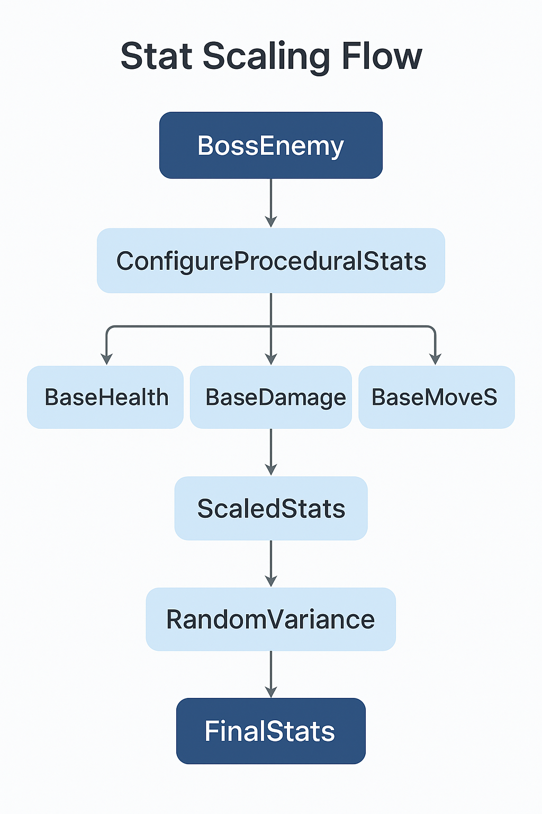
Figure 1: ChatGPT. [SA]. Diagram 1: Stat Scaling Flow. (ChatGPT, 2025)
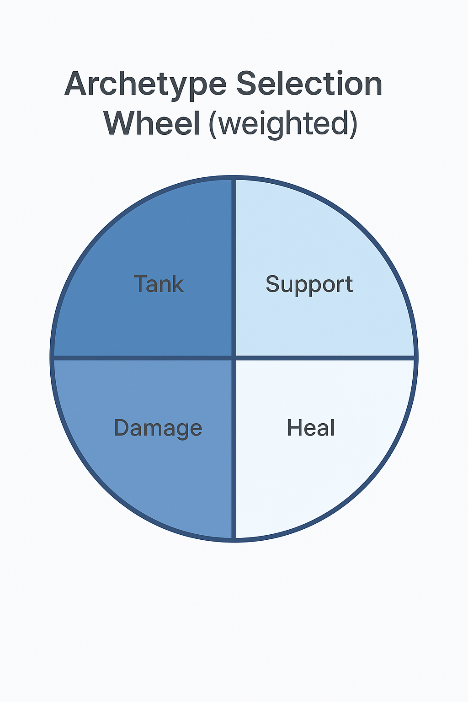
Figure 2: ChatGPT. [SA]. Diagram 2: Archetype Selection Wheel. (ChatGPT, 2025)
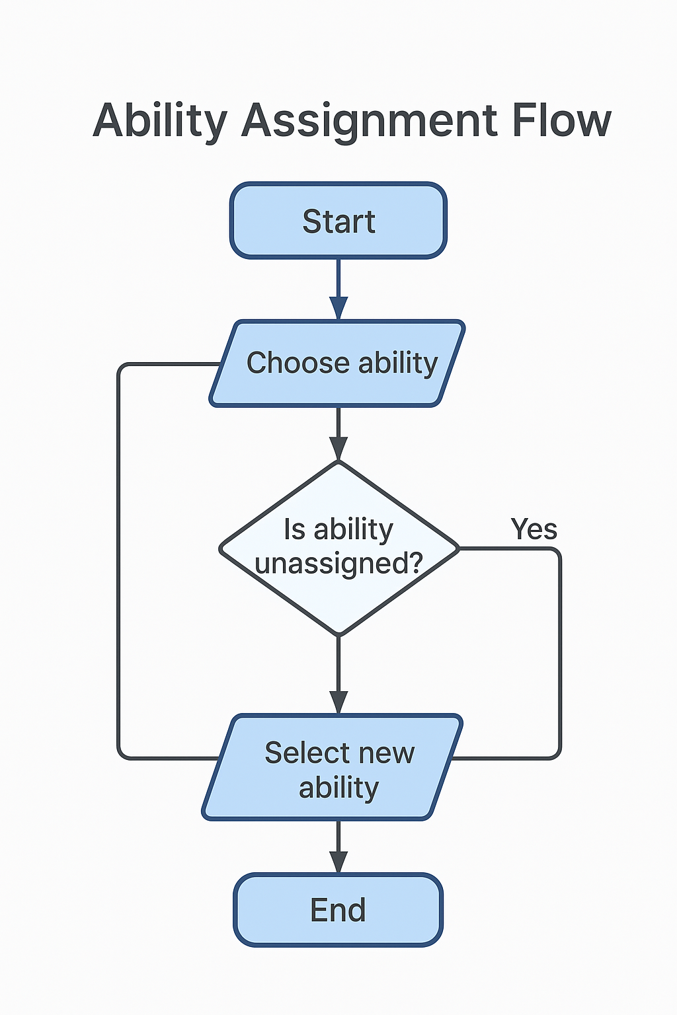
Figure 3: ChatGPT. [SA]. Diagram 3: Ability Assignment Flow. (ChatGPT, 2025)

References
ChatGPT, 2025. Diagram 1 — Stat Scaling Flow. [Online]
Available at: <https://chatgpt.com/>
[Accessed 10 November 2025].
ChatGPT, 2025. Diagram 2 — Archetype Selection Wheel (weighted). [Online]
Available at: <https://chatgpt.com/>
[Accessed 10 November 2025].
ChatGPT, 2025. Diagram 3 — Ability Assignment Flow. [Online]
Available at: <https://chatgpt.com/>
[Accessed 10 November 2025].

List of Figures:
Figure 1: ChatGPT. [SA]. Diagram 1: Stat Scaling Flow.
Figure 2: ChatGPT. [SA]. Diagram 2: Archetype Selection Wheel.
Figure 3: ChatGPT. [SA]. Diagram 3: Ability Assignment Flow.

